

Mastering The Plan Mechanics

“Simple, Yet Advanced Analysis On Network Marketing

Plans To Fire Up Your Network And

Triple Your Income!”

LEGAL NOTICE

The Publisher has strived to be as accurate and complete as possible in the creation of this report, notwithstanding the fact that he does not warrant or represent at any time that the contents within are accurate due to the rapidly changing nature of the Internet.

While all attempts have been made to verify information provided in this publication, the Publisher assumes no responsibility for errors, omissions, or contrary interpretation of the subject matter herein. Any perceived slights of specific persons, peoples, or organizations are unintentional.

In practical advice books, like anything else in life, there are no guarantees of income made. Readers are cautioned to reply on their own judgment about their individual circumstances to act accordingly.

This book is not intended for use as a source of legal, business, accounting or financial advice. All readers are advised to seek services of competent professionals in legal, business, accounting, and finance field.

You are encouraged to print this book for easy reading.

TABLE OF CONTENTS

Not Just About Arrows and Circles 5

Know Yourself, Know Your ‘Enemy’ 6

Using the Knowledge Effectively 8

Unilevel: Unlimited Width and Depth 9

Stairstep: Climbing the ladder of Success 13

Binary: Two at a Time 19

Two-up: The Art of Giving Away 24

Matrix: Reloaded 29

In Closing 32

Recommended Resources + Bonuses 33

Mastering The Plan Mechanics

“Simple, Yet Advanced Analysis On Network Marketing

Plans To Fire Up Your Network And
Triple Your Income!”

Network Marketing Pitfalls

“Discover the Pitfalls & Traps in Network Marketing that You Can Avoid – Saving You TONS of Time, Money & Mistakes!”

Not Just About Arrows and Circles

Dear Network Marketer,

In this explosive guide to Network Marketing, you will learn all about:

- The 5 common types of plans out there to equip yourself thoroughly in your network marketing career

- The common questions that people ask about plans and how to give answers with confidence, especially when challenged by your prospects and downlines

- Recognize that marketing plans are not just about arrows and circles or numbers and percentages but rather an integral part in network building

- Proper strategic placement for your downlines to help you build a solid and stable network as well as double or triple your income

- Win over networkers from other companies to join YOU!

My goal is this: I want you to profit as much as possible from the information in this book. And if what I write here can save you time and money (on training), I would have done my job.

Ponder for a moment: If the knowledge here would equip you well enough to close that ONE BIG SALE (or finding your next superstar downline) would you be overjoyed? Similarly, wouldn’t it would be a great shame, if you didn’t know better, and at that time, you lacked the confidence to sponsor that same person due to lack of knowledge? Words cannot describe the feeling of loss if that were to happen to me.

Don’t leave home without this knowledge! And the best thing is, if you know all this stuff better than me, then PASS THEM TO YOUR DOWNLINES! You cannot lose!

Let’s go! Its time to break a leg! (Or sponsor a new one☺)

Know Yourself, Know Your ‘Enemy’

This was quoted by a famous war general. How does it apply here?

Just as no two people can truly be the same, it is very rare that plans in two different companies can be designed exactly the same arrow by arrow. Let me establish some facts first.

If you were given a choice, would you rather sponsor someone who doesn’t know network marketing or someone familiar with network marketing?

The reason most people would choose the second option is simple, you don’t need to spend so much time training them and they would bring results well on their own.

Now where would I find these types of people? Of course, in other network marketing companies!

But it is not that simple to get those guys over. In life, however, there are no guarantees. You will never know when circumstances will change, when that person might have fallout with his upline or his company might collapse and they might just be hunting for THAT one new opportunity to bring their people to. Timing is important!

Now, some networkers might not agree with me that people might join a new company because of a superior plan. They say it is because of the leadership, influence or confidence that the upline projects. Now I don’t disagree with them. But consider this, how can you be confident, influential or a good leader without thorough knowledge of the plans in the industry? And, if the prospect happens to be obsessed with marketing plans, saying the right word at the right time would nab you a sale!

Now that we have set the record straight, knowing your plan and their plan well will bring you one step to closing a new sale or sponsoring a new distributor from another company.

You may think pinching other people from other companies might be unethical, but this is a dog eat dog world we live in. Given the chance, I believe ‘they’ would love to pinch your downlines as well. (DO NOT attempt this WITHIN your company as line pinching in the same company can often lead to termination of your distributorship) I am not running a course on ethics here; it is up to you to decide what is best for your business. But my belief is this: if I believe my company offers a better product and opportunity to earn income, I would recruit other networkers. Competition is good for companies anyway.

Equally important also, I don’t want to lose my downlines to other networkers as well. Of course, if they decide to leave for whatever reasons, I won’t hold them back because it is THEIR business, not mine. But I want to make sure they don’t get pulled over because of my incompetence as a leader and lose my source of income as a result. This usually occurs when the upline leader is ineffective and deserves to lose his downlines to other networkers because they never trained them well enough in the first place.

Now that we are clear about knowing our own plan and all the other plans ‘out there’, I strongly encourage you to go to as many opportunity meetings as possible to learn all about them (just make sure you don’t get pulled over or your upline will kill you ☹)

Using the Knowledge Effectively

Each plan will be explained in a few sub-headings.

- Plan Structure

There is a diagram associated with each plan. This will explain how the commissions are paid out, as well as the typical network building strategies. I will also illustrate typically what type of companies use this kind of plan structure.

- Advantages

Plan advantages are very crucial to build a long term business. If you haven’t decided which network marketing company to join, or you are thinking of moving to another company (for whatever reasons), this information will give you a very good idea how to build your downline, especially if you are moving your entire network to another company.

- Disadvantages

Not all plans are created equal. There will always be aspects where some plans excel where others don’t. Furthermore, as mentioned in the chapter above, you know where the weak points of other network marketing plans lie and you can use them to your advantage.

- Placement Strategies

Placement of your downline is crucial. Most of the time, this strategy also applies to companies which allow you to have multiple accounts (usually husband and wife, boyfriend and girlfriend, or brothers and sisters.)

NOTE: All plans illustrated here are presented in the rawest form and for you to understand and dissect the basic concepts. The information here is designed to guide only, not as a law. There are many hybrids and variations available in the market today. What I write here is the basic, fundamental structure of where most plans derive their ideas from. Check with your upline or company to be 100% PRECISE about your company’s plan.

Unilevel: Unlimited Width and Depth

The Unilevel plan is one of the oldest types of plans in the market. It basically allows you to sponsor as many people as you want at your level. According to the diagram, there are six people on your ‘frontline’ and more can be sponsored as you like. Your downlines can also sponsor as deep as they want until infinity levels with no restrictions.



In a Unilevel, the commissions are usually fixed percentages of generational overrides. This means that whatever commission paid to you as generated by your downline is determined by how deep they are in your organization. As you can see from the diagram above, the ones where the six circles are at the front line, is given the highest percentage (because those are the people sponsored PERSONALLY by YOU.) You get the most money because they are your hard work. The commissions deeper down the level is smaller because the work was not done by you (or rather, indirectly because the new people are sponsored by your downline, hence a result of your hard work).

A simple mathematics will show actually the bulk of the money is made in the deeper levels, even though the percentage is smaller.

Level 1 You find 6 frontlines: 6 * $100 volume * 25% override = $150
Level 2 Those 6 find 6: 36 * $100 volume * 5% override = $180
Level 3 Those 36 find 6: 216 * $100 volume * 3% override = $648
Level 4 Those 216 find 6: 1296 * $100 volume * 2% override = $2592
Level 5 Those 1296 find 6: 7776 * $100 volume * 1% override = $7776
Level 6 Those 7776 find 6: 46656 * $100 volume * 0.5% override = $23328

At the end of the day, because of the duplication power, you will get paid the most when you build a massive organization at the deepest levels because there are the most people there.

This type of plan is seen in a lot of the older companies (since the 50’s) and they revolve around physical products. Although there are Unilevel Internet companies who use some sort of hybrid plan. Although the Unilevel plan is quite similar to the Stairstep plan in terms of structure, the commission payout method and building techniques differ very much because one is based on fixed levels and the other increases your ‘rank’ based on volume sales.

Advantages of Unilevel

Unilevel is very simple to design, very straight forward calculation. The design allows you to sponsor as wide as you want if you are very aggressive and have a large network. The company determines beforehand, how the percentages are paid out and it trickles down based on the depth of the network so it gives higher rewards to those who are willing to put in the effort to recruit, rather than wait for their downlines to recruit.
Usually the fixed percentages of generations in the network also guarantees some form of income when your downlines move faster than you. Let’s say you recruit one and he recruits three, you earn $25 (1st level) and $15 (2nd level – $5*3), you make $40. On the other hand, your downline makes $25 * 3 which gives a total of $70 which is more than you even though all those guys are your downline.

So, to summarize:

- Unilevels are have a straightforward calculation which lets you know exactly how much you will earn every level making it easier to calculate
- You can build as wide as you want. Even if your downlines are not active, you can still build as many new legs or groups as you want
- People get paid for their hard work in a fair and consistent way
- You don’t have to place people under people in an effort to motivate
- There is no demotion of percentages because they are all fixed.

Disadvantages

There is a limit to how many generations you can split the commissions. So typically when someone is very deep in an organization, the monetary motivations is not that attractive (you only get paid 1% at the fifth level) so if the majority of the work is done by YOU and not yet duplicated to your downline, then you will have to maintain your network by yourself even if it means helping with the same effort for less.

One big difference in the Unilevel compared with Stairstep is most Stairstep requires at least 2 active legs then will commission be paid out feasibly. In Unilevel, ONE active leg pays you all the commission (which is not wrong in itself) but lazy people would just find one downline and leave the group building or nurturing to their sponsor to do all the ‘dirty’ work while he gets all the commission.

- In the deepest levels, you get paid very little or even ZERO (because certain companies only pay up to certain levels and beyond that, you get nothing)
- Because there are less commission at the deeper levels, there is less motivation for the up-upline to close sales for them unless they want to secure their group
- If all the people in the middle of your organization abandon their downlines, you will have to help those there and you will earn little while the sleeping partners earn commission without putting in any more effort
- As mentioned in the paragraph above, lazy ‘one legged pirates’ can be troublesome freeloaders
- If you have to place people under your downlines (all three of you could be friends), you earn much less because instead of getting 25%, you get only 5%
- It is virtually impossible to duplicate a perfect structure (even 6 * 6 is already a struggle).
- If you do not duplicate your efforts well in your frontlines, you will be the only upline making money from your sunflower shaped organization.

Placement Strategies

Placement for Unilevel is very straightforward. You can buy up as many accounts as you want and place them one after another shaped like a Popsicle. This will allow you to get commissions from the same person twice or three times.

Account 1 – 25%

Account 2 – 5%

Account 3 – 3%

Account 4 – 2%

NEW DOWNLINE

So total you can earn up to 35% commission because all the 4 accounts belong to the same person. The new downline recruits someone and you can easily get up to 11%.

Note: Do not attempt opening many accounts if you are forced to do MAINTENANCE every month or else you will go bankrupt before you build a big group!

Stairstep: Climbing the Ladder of Success
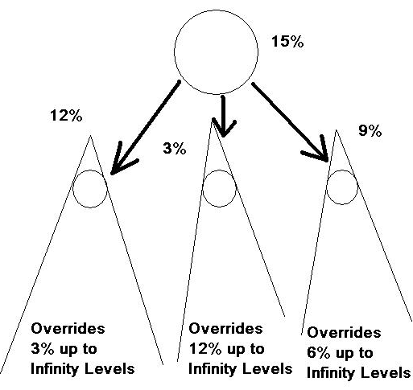

This is the typical layout for Stairstep plans. Their percentages are not fixed from the time you join till much later in your business because the percentages you get differs based on how you build up the volume within your groups.

Let’s use some numbers for illustration sake.

3% level- $1000 minimum volume required
6% level- $3000 minimum volume required
9% level - $7500 minimum volume required
12% level - $12500 minimum volume required
15% level - $20000 minimum volume required
In Stairstep, you calculate your commissions based on the entire group regardless of who did the volume within the group. You just need to keep track on your frontline and what his percentage is to determine how much commission you get. The difference between your percentage and what you ‘payout’ to your entire group is the difference you keep multiplied by the total volume of that group.

Here is an example:

You have personal sales of $1000.
The leg on the left achieves $15000 and is in the 12% category.
The leg in the middle achieves $2000 and is in the 3% category.
The leg on the right achieves $9000 and is in the 9% category.

Therefore your TOTAL GROUP SALES is $27000 and that puts you in the 15% range.

You make 15% over your personal sales of $1000 which is $150
The left leg, you make $15000 * 3% (which is 15 minus 12) difference between the group which is $450
The one in the middle, you make $2000 * 12% (which is 15 minus 3) difference between the group which is $240
The one on the right, you make $9000 * 6% difference which is $540

Grand Total: $1380

Now that we get the idea how the stairs work, notice this:

Upline

DOWNLINE

12% Upline has only sponsored one downline personally
Upline achieves 12% status because ‘pushed-up’ by his
downline.

Downline sponsored five hence has a ‘bigger’ group
12% Overrides 9% from each downline – makes more
than his upline!

Each of the 5 at this level contributes $2500 volume
They are at 3% each
Climbing the Stairstep ladder will reward those who build more width and develop those groups. The downline who works harder than his upline can earn more and climb the ladder faster than his upline.

Assuming a typical ladder looks something like this

3% → 6% → 9% → 12% → 15% → →
LEADER 3% bonus→ → MANAGER 2% bonus → → ACHIEVER 1% bonus
Lets say you achieve LEADERSHIP for maintaining a 15% group for 3 months and You achieve MANAGERSHIP for developing 5 LEADERS

Leader (only have one ‘leader/manager’ downline)

Manager (higher rank than upline)

5 LEADERS belonging to Manager’s group

To summarize:

Stairstep differs from Unilevel in these aspects:
Unilevel has fixed generation (normally 5-10 levels) overrides while Stairstep allows you to override up to infinity levels if your rank or position is higher than your downline group.

Stairstep is the most popular plan in the market today, used by the oldest to the most successful companies today. They are also mostly physical product based.

Advantages

According to most plan experts, the Stairstep plan is one of the most stable forms of marketing plan in the market today. They have a very good breakdown of commission paid level by level and reward those who not only recruit but develop those recruits. They are stronger than Unilevel in the sense that even when their frontlines are not moving but the downlines under the frontline are, the payout is not as vulnerable to smaller depth commissions as in the Unilevel is because as long as your rank is higher than your frontline, all sales volume there are calculated the same all the way down to infinity levels. Most important of all, this plan rewards based on performance more so than other plans.

So to list down all the good points:

- Stairstep is most popular and is based on hard work and leadership
- You can draw commissions up to infinity levels deep
- When you motivate the guy at the bottom of the line, all his uplines up to you will get really fired up because all will receive the benefits of his bonuses.
- Achieving a ‘position’ is a very glorious event in step and ladder because most network marketing companies glamorize their position (e.g. Being a Diamond World Team Manager sounds really awesome)
- You can build as wide as you want AND as deep as you want and make profits!
- If you recruit a group of friends, you can place them in the same line and there will not be conflict of interest among the same group while everyone benefits

Disadvantages

Sunflower frontline syndrome is very common because there is no way you can duplicate human beings 100%. When people drop out, they just move on and sponsor another, so the failure rate is very high in Stairstep plans. In other words, a new guy joins, tries for a while and quits and his upline feels he is not the one then he abandons him and moves on to another and another until he finds the one.

Breakaway is also a serious issue in most Stairstep plans. I will illustrate in a diagram below:

A
B
C

Upline Manager 2% ‘A’ needs 5 managers to qualify
To be an Achiever (higher rank)

Other groups ‘C’ works faster than ‘B’ to reach
The rank of Manager first
Leader 1%

WHAT HAPPENS?

Manager 2%

‘A’ has a tendency to NEGLECT ‘B’ because he has already fulfilled his criterion of building 5 managers with one of them fulfilled in ‘C’. In other words, ‘A’ doesn’t ‘need’ ‘B’ anymore and goes on to focus on OTHER GROUPS and developing managers there.

To summarize the biggest weaknesses of Stairstep are these:

- If there is no demotion in the plan, it encourages inventory loading. This is very common where people are short of certain sales volume and he buys the remainder up for that month.
- Inventory loading is very dangerous if done incorrectly because he is not buying the product for his own personal usage but for gaining points. If this happens on a global scale, a lot of products will DEVALUE because often people who overstock will ‘get rid’ of the product selling it at a cheaper price.)
- No spillover (discussed in the next chapter)
- Breakaway encourages SABOTAGE where the upline deliberately tries to slow down (as in ‘B’s’ case on ‘C’) the downline directly or indirectly.
- You often need to work with many, many different legs at the same time because most plans need you to go as wide as possible in order to succeed.

Placement Strategies

Start building ONE account at a time. Once your minimum required width is secure, you can open a new account under the 1st one and park those under there.

Husband

Wife

The wife in this case is the 6th account because if the company needs to secure 6 wide, the new account can belong to the wife. The new frontlines can be parked under the wife because normally people expand new legs past the minimum width requirement.

You make double income from there on when all the groups are secure and you can achieve your next rank faster when you build your wife’s account.

Binary: Two at a Time

A binary is a unique type of plan that limits your width to 2 people but you can draw commissions up to infinity levels. Most of the time, additional people sponsored by a distributor must place those people UNDER their downline. This is called a spillover.

e.g. ‘A’ has 2 downlines A1 and A2. ‘A’ is very aggressive and finds 2 more, he places them under A1 and A2. Therefore, both A1 and A2 gets new downlines without personally sponsoring anybody.
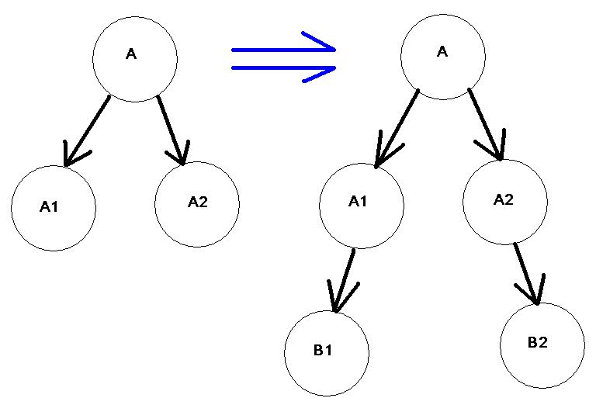

How does the payout of commissions work?

The payout is done by the comparisons of both sides of each separate leg. One leg usually products more volume than the other. The diagram below will illustrate:

Group A is the Strong Leg or Power Leg Group B is the Weak Leg or Profit Leg

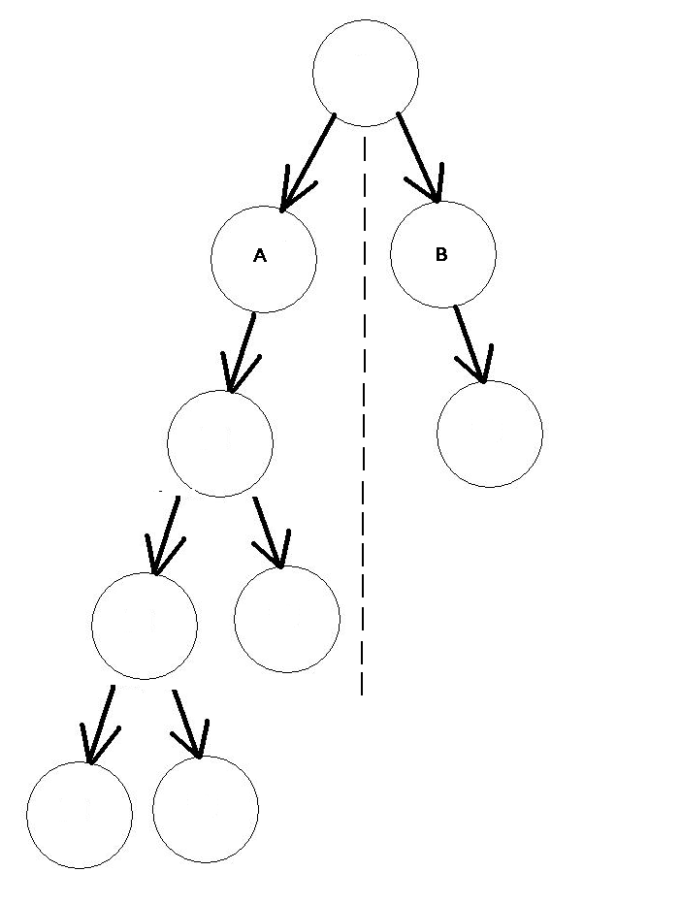

Lets Say group A generates a volume of $5000 and group B generates $1000.
If the upline gets 20% overriding, he gets paid only 20% of $1000 which is $200 even though the his entire group’s total volume is $6000

If he wants to earn more commission, he must focus on building the weak or profit leg by placing more people there or increasing their sales to MATCH the strong or power leg. This is often known as Balancing or Matching.
All types of companies use this plan structure ESPECIALLY Internet network marketing companies which deals with digital products. Why this form of plan is popular with Internet companies is because the lack of human interaction and massive numbers on the Internet can stack downline below downline (automated signup) causing a very large group to be generated within days or even just minutes!

Advantages

The main advantage of the Binary plan is that you only need to BUILD TWO LEGS. In theory, you only need to find two and those two find two and so on. It is significantly more realistic to build and duplicate two compared with building five or six.

The element of spillover is also good in the sense that when a new company starts and the pioneers have a lot of interested prospects, they can build a MASSIVE organization within a few days by placing people in the right structure.

- Binary is easier to build compared to Unilevel or Stairstep
- The upline’s business can support the downline through spillover, compared with Unilevel and Stairstep where the your upline will rarely place people under you
- You can receive commissions up to infinity levels so it doesn’t matter who generates the volume as it is all considered within the same leg
- If you belong in the profit leg, your upline can go all the way down (even if you are many generations away from him) and help you to build your group as though he has personally sponsored you because it doesn’t matter how deep you are as long as your groups grow, HIS commissions grow as well.
- You can purchase additional accounts or tracking centers to maximize your commissions (explained in the later section below)

Disadvantages

There are many disadvantages of binaries noted by experts:

- Spillover encourages laziness and attracts lots of freeloaders because they keep expecting their upline to place people below them
- A lot of the commissions in the Power Leg or Strong Leg usually goes back to the company if they are not matched or balanced
- Binaries are ‘generally’ considered unstable and short-term where you build a fast and big network but collapses due to saturation and difficulty in balancing
- You have little control on where your downline places the spillovers
- Companies that do not calculate their plan properly may wind up OVERPAYING their distributors causing the company to COLLAPSE due to financial problems. This is due to paying out up to infinity levels.
- Mathematically speaking, if a company is unscrupulous, they can terminate a distributor if his group gets way too big to the point he is earning more money that the company itself!

Note: Binaries are not dangerous; it is PEOPLE that abuse plans or poor planning by poor management that causes these kinds of rumors. Ultimately, it is how you lead your people and your partnership with the company that determines a long term business.

Placement Strategies

Most people strongly recommend building a network with three accounts or tracking centers. How does this work out? See the diagram below:

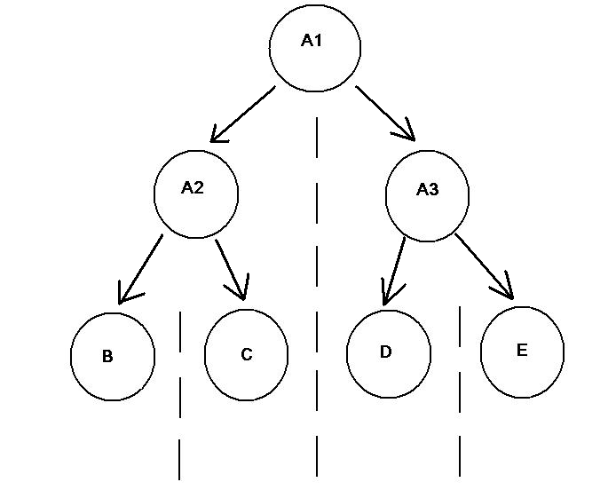
Account A1, A2 and A3 are owned by the SAME PERSON. He has to recruit 4 people but he can earn maximum up to THREE TIMES the commission compared to just having 1 account. Assuming B, C, D and E each does $100 volume.

A1 earns on $200 (because of A2 and A3’s total volume is $200/$200)
A2 earns on $100 (because of B & C’s total volume is $100/$100). A3 as well.

HIS TOTAL COMMISSION is calculated on $200 + $100 + $100 not to mention A1 overriding over A2 and A3’s commission as well. If he had one account only, he will only make money based on $200 group volume and no additional accounts to override from.

MOST PEOPLE WILL RECOMMEND ONE GUY HAVING 3 ACCOUNTS BECAUSE IT MAXIMIZES THEIR COMMISSIONS AND IS EASY TO DUPLICATE

People who buy only one tracking center will lose out a lot of commissions and they are typically people who want to try the product at discounts but are not serious builders. There are also people who invest in 7 accounts but need to find a lot of people themselves (about 8 legs required to sponsor).

Two-up – The Art of Giving Away

The two up plan is not very straight forward but is very rewarding if built correctly.
A
B

A is B’s Upline

A
B
B1
B2
B makes 2 sales – B1 and B2

In this system, the sales of B
Goes up directly to A

A
B
B1
B2
‘B’ Sponsors his third downline which
C
Is ‘C’, he earns the sale from ‘C’ Notice
C is the THIRD downline he sponsored
After ‘B’ has given away his first 2.
All downlines recruited by B1 AND B2
WILL ALL GO TO ‘A’

A
B
B1
B2
C
C1
C2
C3
C4
C5

D
B3
B4

B5
C6

Basically you give away the entire group of the first TWO people to your sponsor.
All the ‘B’ group people will be given to ‘A’ while all the ‘C’ group will be given to ‘B’.

Any downlines you sponsor beyond your first two, those groups will all belong to you, If you were to sponsor A, B, C, D, E, F:

The first 2 groups of C, D, E, F and THEIR first two sales will all go up to YOU.

You can build this plan AS WIDE AS YOU WANT and you can also get the SAME LEVEL OF COMMISSIONS also AS DEEP AS YOU WANT.

This plan not as common as Unilevels, Stairsteps and Binaries, but they tend to occur in offline or online programs that are doing ONE TIME SALES because the nature of giving away downlines is very tricky and is used to build the network. Two-ups usually appear in hybrids with other plans just like Unilevel benefits and Stairstep benefits are often synergized.

Advantages

This plan is very good because of the unlimited width and depth where you are able to draw commissions. Basically the people after your first two, if duplicated carefully can grow to a massive organization like this.

A
1

16

32

With just 2 people bringing 2 people, you can build up to thousands in theory. Notice also that this is the only group which you can build. You can develop as many groups like this as you want.

- This has all the advantages or Unilevel and Binary (infinity levels) without the weakness of lower commission at the deeper levels.
- The duplication effect is very powerful as 2 become 4 then 8 and so on.
- You can have multiple streams of this duplication as well depending on how many people you want to personally sponsor.

Disadvantages

Besides often mistaken as a Binary (for people who are afraid of Binaries) the biggest disadvantage of the Two-up is obvious. Human beings are selfish by nature and will try to give the weakest of their downlines as their first two. This kind of thinking is extremely wrong and I will draw a picture below to show you why, when duplication occurs can go hay-wire:

C
Notice: ‘B’ has 3 downlines in front

Actually, B has only sponsored ONE!
The two triangles that he is supposed to give away
B
B
are actually accounts he bought himself!

B earns sale from his new downline C and thought he
‘Got away’ from ‘losing’ his sale to his upline…
B

But watch what happens next…

D
C found out what B did…
AND DUPLICATED THE SAME!

B gets 2 more new sales,
B
B
B
C
C
BUT THAT IS ALL HE IS EVER
C
GOING TO GET FROM C

What happens is that this is going to duplicate a HOLLOW ORGANIZATION of what is called CATS AND DOGS!

All you get are fake downlines. Those in Red are not real and you can’t get commission elsewhere.

At the end of the day, don’t be greedy or selfish because what example you set is going to be duplicated.

One more reason why this plan has a big weakness is the downline who may not play with ‘cats and dogs’ put the WEAKER downlines as his first two. Normally companies set conditions to keep the 1st two active in the network to keep the business running. If you leave your weakest first, they will drop out very quickly and you will be forced to replace them or else you will lose your bonuses or overriding commissions!

Placement Strategies

Remember when placing your downlines, DO NOT follow the example in the diagram on the page before.

Now a good placement strategy will be like this. If you can afford to maintain 2 accounts, it would be wise to place the third downline (your wife/husband/boy/girlfriend/) AFTER you have got two strong downlines to secure the 1st two slots.

Note however that this kind of strategy is useful only if the two-up plan is combined with some sort of Unilevel plan where you get generation bonuses. Otherwise it is not feasible to buy so many accounts as Two-up plans only pay the commission to one person and not two.

Matrix: Reloaded

Matrix plans are very numerous and are most often found on the Internet. A matrix has a limited width and depth. When someone says a 2X2 matrix, it means that the maximum width you can have is two downlines and the maximum you can build unto is 2 levels deep.

Matrix Completed (2X2)

Re-entry new Unit
Matrix Cycle begins
Again

When this happens, the matrix is considered COMPLETE. You get paid a commission when the matrix is completed and you are often given another new account to run the matrix again. This is known as RE-ENTRY. This new re-entry unit is placed (depending on the marketing plan) either under your sponsor or in any matrix you wish to complete.

When each person focuses on completing his matrix or his downline’s matrix, the matrix cycles more and more often and each person can get paid many times over.

Some matrixes are automated by the computer system all you need to do when you sign up a new person is to write who is the introducer (you) and the system automatically fills the matrix for you.

When you find your minimum number of people to qualify, you ‘move up’ the matrix until you fill your matrix.

There is one more popular variation of matrix that goes under ONLY ONE big tree. This matrix uses a pre-order tree and ‘forces’ the new recruits to fill the next position.
A
A
A recruits B Later, B recruits C
But is placed to fill
The next slot
B
B

C

A, B and C each recruits one respectively and later the matrix looks like this
A
B
C

This is also known as a forced Matrix
They will pay out to you after the Matrix
Has reached a certain level
And the downlines are all spilled over
ROW BY ROW.

A1
B1
C1

There are just too many variations of Matrixes out there that I can only describe briefly how the system works. Many different versions have differing width and depth (e.g. 3X10 or 2X3) and pays out differently. They don’t have uplines or downlines in the traditional sense in network marketing but they track the people via their referrers.
Advantages

Matrix plans that are participated by lots of people can duplicate easily and as soon as the matrix starts cycling, it will cause a chain effect filling one another’s matrix and everyone will earn lots of commissions very fast. The key is in the duplication. Re-entries speed up the whole process and by duplicating the speed with each person finding a minimum of two and those people find their people as well, the money can move up to the craziest amounts.

Basically, Matrixes are:

- The fastest type of plans around
- You get spillover very easily
- Re-entries make the payout faster and gives you more opportunity to make more income without looking for as many people
- If you join early and recruit fast, you can earn a lot of fast money in a short time

Disadvantages

Most matrixes either collapse or become unsustainable after many cycles.

- In Forced Matrixes, the more people you recruit, the wider the base of the pyramid becomes and it will be very hard to fill the bottom (even with re-entries) especially when everybody are waiting for spillover, they stop recruiting. The whole system will come to a grinding halt when people stop recruiting
- The cycles will also stop cycling after awhile due to saturation
- Most ILLEGAL PYRAMID SCHEMES or PONZI SCHEMES like to use Matrixes to roll money because often there are no products involved.

Placement Strategies

There is only one good way to play a matrix plan, join early and work as hard as you can. There are too many types of matrixes out there to give a very specific strategy. If the company offers a forced matrix, try to buy as many accounts as you can early in the start so you can cycle early. Otherwise, don’t get involved with a Matrix especially when it is heavily saturated. MOST IMPORTANT OF ALL, do your due diligences when checking out a company especially if it is online to see if it is a pyramid scheme or Ponzi scam.

In Closing

WHEW! What a ride!

Thank you for reading if you have read everything from the top to the finish. If you find these to be heavy stuff, it is even more worth it to know what is out there. Anything that makes money definitely requires hard work and careful study.

That’s right; we have come to the end.

Let me just share a few more tips before we part ways:

Remember in network marketing:

- It is not sufficient to have a plan; you must WORK YOUR PLAN!
- Plans only work when you are recruiting. SEE THE PEOPLE!
- If you don’t work hard, any plan won’t work. DON’T BLAME THE PLAN!
- SHARE THE PLAN with your downlines. They may need this info more than you do!

Now that you are armed with all the information you need, your network marketing success awaits you. Start TAKING ACTION NOW!

Wish you all the best!

Recommended Resources

3 Steps to Profiting From Your Resell Right Business – how to profit from buying and reselling digital products in 3 absurdly simple but profound steps, NOT FOUND in most PAID products!

Edmund Loh’s Guide to Private Label Rights v3 – your essential guide to buying and selling Private Label products in the Internet marketplace. This is one of the earliest and often updated manuals on Private Label Rights in the Internet Marketing community!

19 Internet Business Models – eliminate guesswork and discover what makes the world go round for Internet Entrepreneurs and copy their success business systems for your own in a flash – low cost, high profit!

All-in-One E-Commerce Solutions

SOLOBIS – all-in-one solution comes with unlimited web hosting, domain name, unlimited auto responders, broadcast feature, custom web builder, file manager, link cloakers, JV manager, 500+ beautiful web templates, online support team, and many more. No HTML and programming knowledge required.

Recommended Payment Processors

2CheckOut.com – start accepting credit card payments from customers from several parts of the world!

Congratulations!

“Your Purchase of this Book Entitles You to a FREE Lifetime Membership Privileged Access to ResellRightsMastery.com As a Gold Member… Worth $197.00!”



Dear Valued Reader,

I would like to invite you to join my active membership site, ResellRightsMastery.com, as a privileged Gold member! Your Gold member benefits entitle you to:

- Consistently adding collection of Resell Rights items you can sell and pocket all the sales,

- Adding array of Private Label articles you can edit, put in your resource box, compile into Info products, and submit to article directories for exposure,

- Advanced Reseller strategies issues on how to gain all the edges as a reseller,

- And much, much more!

This membership access is valued at $197.00 but as a gesture of thanks for joining me in this short, fast but thrilling adventure through the pages of this book, this membership privilege is yours $197.00 FREE of CHARGE. Consider it a bonus, but you’ll want to be connected to the Internet right now to take advantage of this bonus!

So get connected to the Internet if you haven’t just yet, and click on the link below to sign up – no catches!

Click Here to Join ResellRightsMastery.com as a Gold Member FREE

This is my way of saying thanks and I look forward to your joining in ResellRightsMastery.com! ☺

P.S. Once you’re inside the member’s area, you’ll discover all the possibilities of building your Internet Business on steroids.

SPECIAL BONUS YOU DON’T WANT TO MISS OUT!

ATTENTION: All Network Marketers!

“Discover How YOU – Or ANYONE –Can Become A Network Marketing MAGNET Where Your MLM Prospects Will Beat A Path To Your Doorstep And Hunt You Down… Instead Of You Hunting THEM!”



Join The “Magnetic Sponsoring Boot Camp” Now For The Next 10 Days And Learn How You Can Become The Next Lead & Cash Generating Machine… FREE!

Click Here To Join The 10 Day Magnetic Sponsoring Boot Camp Now!

